**RAJSHAHI UNIVERSITY OF ENGINEERING AND TECHNOLOGY**

**Course No :** CSE 3110

**Course Title:** Sessional Based on CSE 3109

**Problem No :** 02

**Problem Name :** Write a program to display a “?”, read two capital letters and display them on the next line in alphabetical order.

**Submitted To:**

Sadia Zaman Mishu

Assistant Professor

Computer Science and Engineering

Rajshahi University of Engineering and Technology

**Submitted By:**

Name : Md. Fakhrul Islam

Roll: 1803071

Session: 2018-19

Department : Computer Science and Engineering

Rajshahi University of Engineering and Technology

**Problem No:** 02

**Problem Name:** Write a program to display a “?”, read two capital letters and display them on the next line in alphabetical order.

**Description:**

An assembly language is a type of low-level [programming](https://www.investopedia.com/career-advice-4689809) language that is intended to communicate directly with a computer’s hardware. Assembly Language is a necessary bridge between the underlying hardware of a computer and the higher-level programming languages. In assembly language, data are stored in register and use the data to solve arithmetic and logical problem. Memory-Memory, Memory-Variable, Variable-Memory data transfer are allowed. But, Variable-Variable data transfer is not allowed in assembly language. ADD, MOV, CMP, SUB, MUL, DIV these keywords are used for different purposes. ADD is used to add two number. CMP is used to compare. Different kind of jump functions are used to check the condition. JG means if greater than and JL means jump if less than. In this program, ADD, CMP, JG, MOV are used.

MOV AH, 1 for input and MOV AH, 2 for output.

**CODE:**

|  |  |
| --- | --- |
| .MODEL SMALL  .STACK 100H  .DATA  .CODE  MAIN PROC    MOV AH,2  MOV DL, '?'  INT 21H    MOV AH, 1  INT 21H  MOV BL, AL  ADD BL, 32    MOV AH,1  INT 21H  MOV CL, AL  ADD CL, 32    MOV AH, 2  MOV DL, 0AH  INT 21H  MOV DL, 0DH  INT 21H | CMP CL, BL  JG NEXT    MOV AH, 2  MOV DL, CL  INT 21H  MOV DL, BL  INT 21H  MOV AH, 4CH  INT 21H    NEXT:  MOV AH, 2  MOV DL, BL  INT 21H  MOV DL, CL  INT 21H  MOV AH, 4CH  INT 21H  MAIN ENDP  END MAIN |

**OUTPUT:**

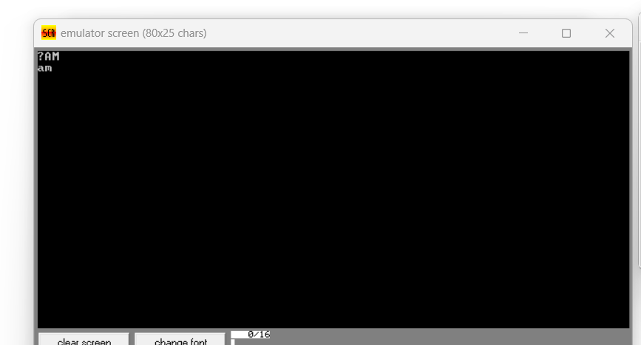

**Conclusion:**

In this program, capital letter is converted small letter by adding 32. The small letter is ordered in lexicographical order. There is a slight limitation in the program. Small character as an input will give wrong answer. Because, by adding 32, it will give higher ascii value. The problem can be overcome by checking whether the character is capital letter or small letter. If the letter is capital, 32 will be added. Otherwise, there is no need to add anything. In this way, the limitations will be solved.